Working with the five senses and collecting descriptive adjectives using pictures and music

Notes for the teacher:
- Ask the pupils to look at the picture. (Enclosure 1)
The picture can be shown by using an over head projector or preferably using a computer and a projector.
If you want to use music while you read or as an extra assignment or an extra effect, when working with different senses, you can use the links from Enclosure 4 or you can co-operate with the music teacher at your school and see what suggestive music he/she can come up with. The multi-cultural side of music is vast.
- You start by telling the pupils a story about a visit to Norway when you met one of the Norwegian trolls. There might be music in the back- ground.
When the darkness slowly kreeps closer in the forest in Norway, the trolls come out. They cannot be seen in daylight. If they are out when the sun rises they will turn into stone.
Once upon a time my grandmother told me about these Norwegian trolls, but I never expected to meet one myself.
I was spending a week in Norway and during a cold, misty, enchanting night I came to experience the most extraordinarily thing in my life. I was watching the beauty of the forest dressed in its winter robe when suddenly something started appearing amongst the trees.
A three meter tall troll, looking several hundreds of years old, was coming towards me. In his right hand he held a walking stick made from a whole tree and …
You can continue the story any way you want, or you ask the pupils to continue.
Go through words from your presentation. Were there many difficult words? Which words were used to describe things?
- Ask the pupils to draw a troll in groups. Ask the pupils why they drew the troll in this way (stereotypes and assumptions) and compare them with the drawing in enclosure 2 and 3.
Ask the pupils: Do you know a creature like this? What is it? Who is it? How do you know it? Have you met something like this here in Sweden or in the country you and/or your parents come from?
- What song or music would you like to combine with your troll? Could you make up your own song or music that would suit your troll? Which adjectives would you use to describe your music?
- Instruct the pupils:
Write adjectives describing your own group’s troll in as many languages as you can. Use as many descriptive adjectives as you can. Use as many senses as possible:
- Hearing
- Sight
- Smell
- Taste
- Touch
Write the adjectives in English and in the different mother tongues in your group. Use different colours for each language. Put the word categories into a booklet.
- Present your words to the class. The pupils in each group will read each adjective in each language and the class will repeat the words in chorus.
Are there similarities between the different adjectives you have written? Can you make groups with similar adjectives and find their origin or the language families they belong to? Get the information on the web.

Homework
Which is your favourite fairy tale from your home country? Ask your parents about their favourite fairy tale when they were kids.
Draw your favourite character and your parents’ favourite characters. Make a presentation in your own language where you describe the characters with as many adjectives as possible. Who is/are the hero/heroes and who is/are the trouble maker/s?
Extra: Could you bring some examples of music that could be used, when you describe your characters?

Resources

Enclosure 1
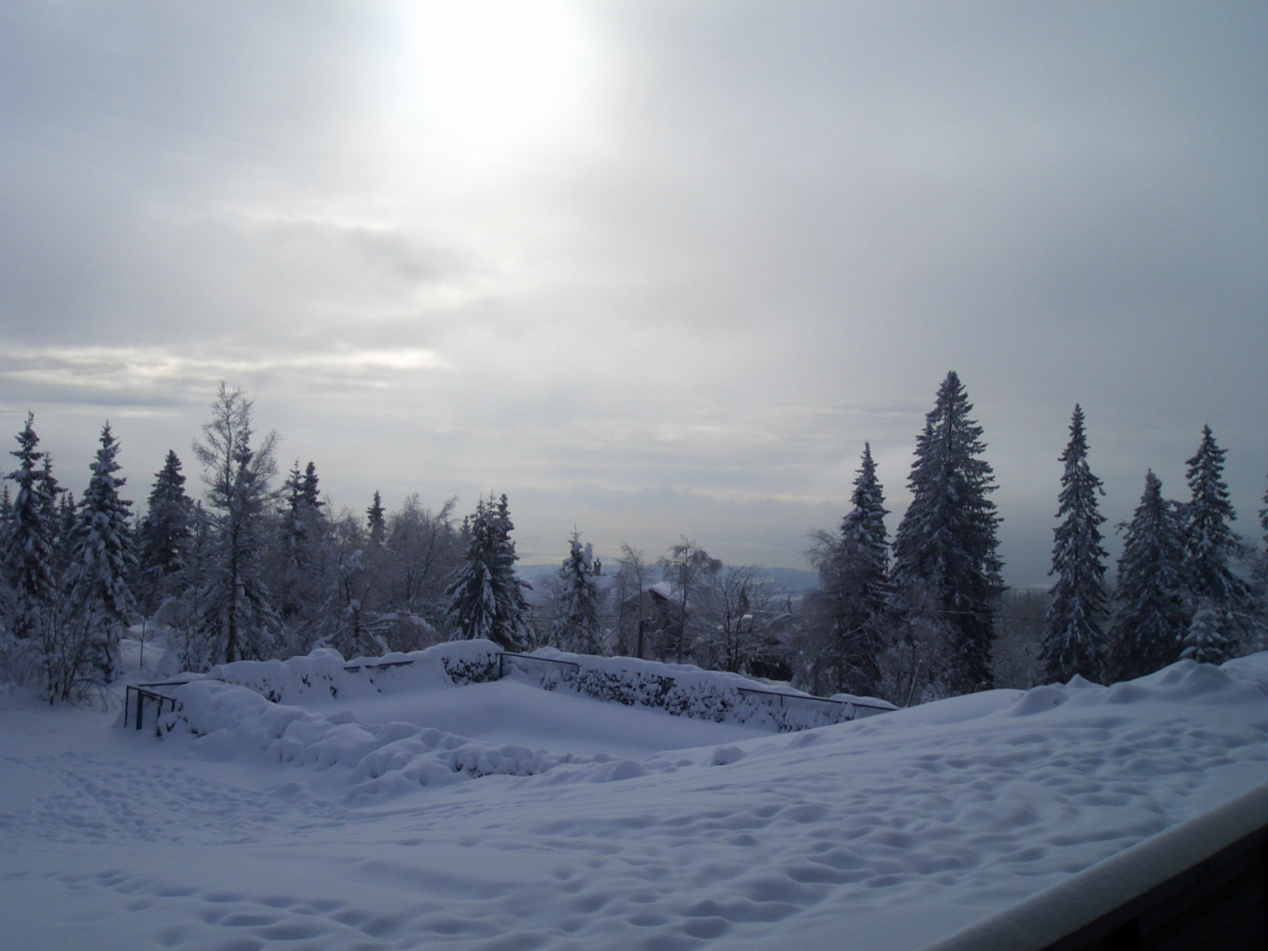
Photo taken by Pia Berg, January 2009

Enclosure 2
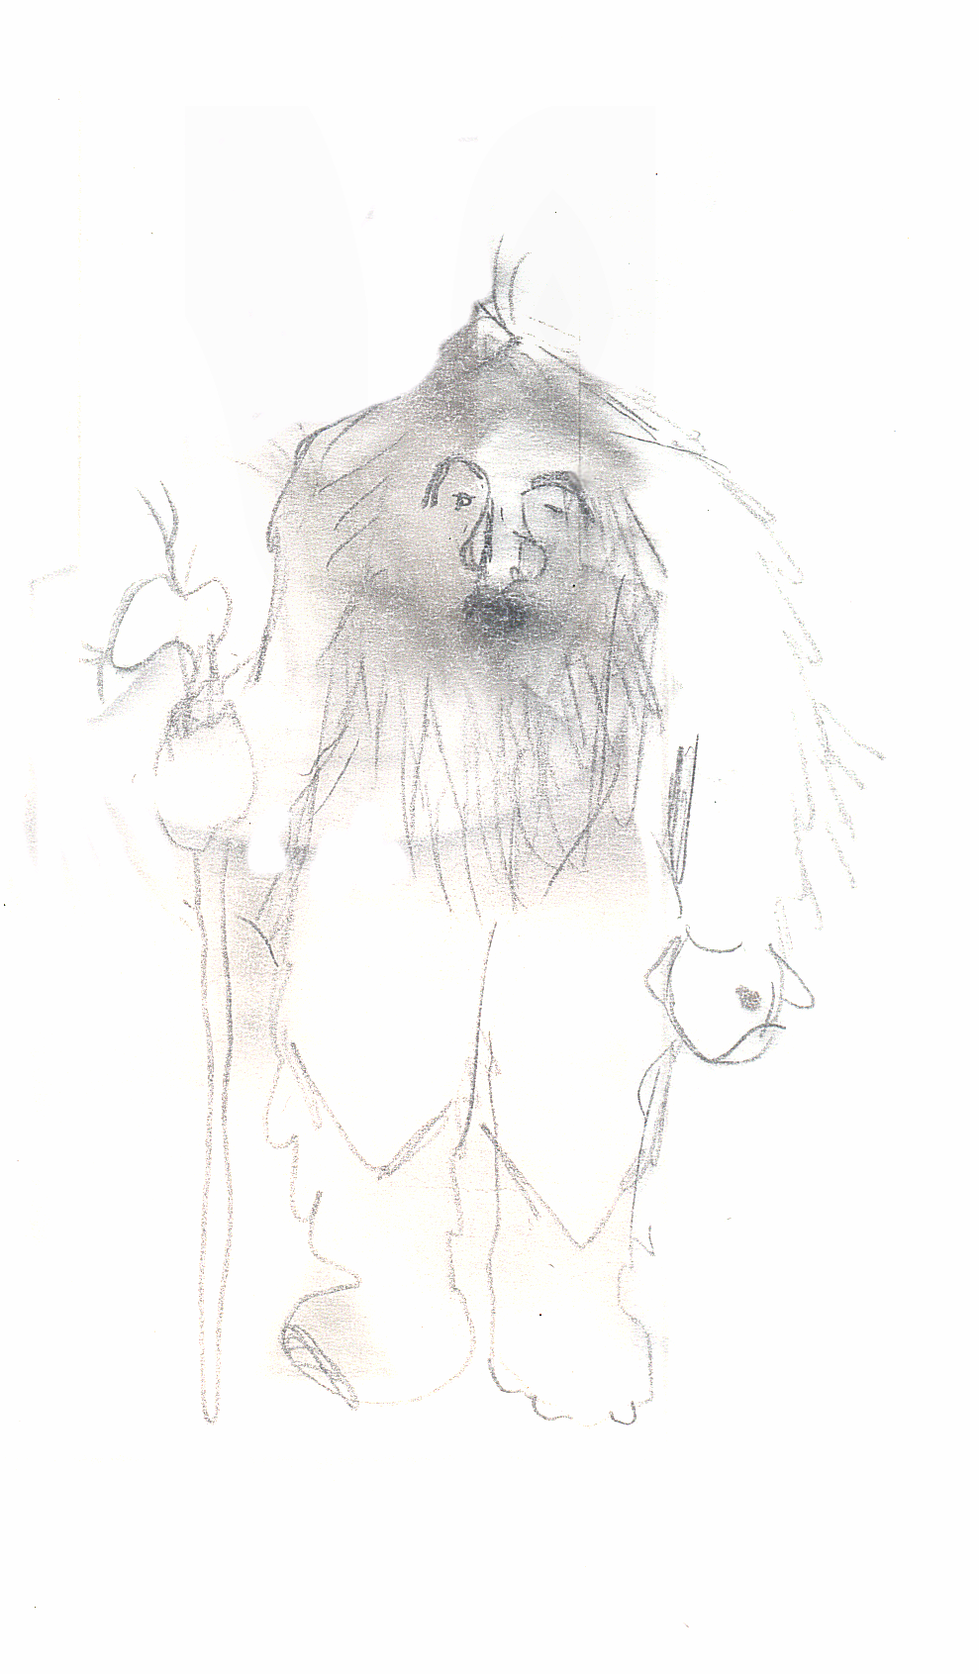
Drawing made by Pia Berg

Enclosure 3
Photo collage made by Pia Berg, 2009

Enclosure 4

In the Hall of the Mountain King
In the Hall of the Mountain King (Norwegian: I Dovregubbens hall) is a piece of orchestral music, Opus 23, composed by Edvard Grieg for Henrik Ibsen's play Peer Gynt, which premiered in Oslo on February 24, 1876.
A fantasy play written in verse, Peer Gynt tells of the adventures of the eponymous Peer. The sequence illustrated by the music of In the Hall of the Mountain King is when Peer sneaks into the Mountain King's castle. The piece then describes Peer's attempts to escape from the King and his trolls.

The music
The famous two-phrase theme, written in the key of B minor, runs thus:
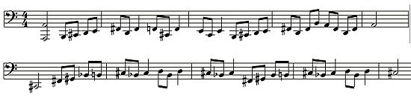
The simple theme begins slowly and quietly in the lowest registers of the orchestra. It is played first by the cellos and bassoons, signifying Peer Gynt's slow, careful footsteps. After being recited, the main theme is then very slightly modified with a few different ascending notes, but transposed up a perfect fifth (to the key of F-sharp major, the dominant key, but with flattened sixth) and played on different instruments: these are the King's trolls.

From: Wikipedia, the free encyclopedia
http://en.wikipedia.org/wiki/In_the_Hall_of_the_Mountain_King

From: youtube.com
In the Hall of the Mountain King
http://www.youtube.com/watch?v=xrIYT-MrVaI&feature=related
http://www.youtube.com/watch?v=SBUp9zhEy9U&feature=related
http://www.youtube.com/watch?v=Xs2OBy_mlrc&feature=related
March of the Trolls
http://www.youtube.com/watch?v=KS036Cq49qU&feature=related

